1. **Design the form of Employee Salary Statement using HTML and JavaScript.**

**Code :**

<html>

<head>

<style>

input[type=button] {

    width: 10%;

    background-color: #a2937a;

    color: white;

    padding: 8px 0;

    border: none;

    border-radius: 50px;

    cursor: pointer;

}

input[type=button]:hover {

    background-color: green;

}

div {

    border-radius: 5px;

    background-color: #f2f2f2;

    padding: 20px;

}

</style>

<script>

function cal() {

    var bs1, pe1, hr1, in1, t1, te1, er1, td1, ns1;

    bs1 = Number(document.getElementById("bs").value);

    pe1 = Number(document.getElementById("pe").value);

    hr1 = Number(document.getElementById("hr").value);

    in1 = Number(document.getElementById("in").value);

    t1 = Number(document.getElementById("t").value);

    er1 = Number(document.getElementById("da").value);

    te1 = bs1 + hr1 + t1 + er1;

    document.getElementById("te").value = te1;

    td1 = pe1 + in1;

    document.getElementById("td").value = td1;

    ns1 = te1 - td1;

    document.getElementById("ns").value = ns1;

}

</script>

</head>

<body>

    <br><br><br><br>

<h1 align="center"><font color="blue">Employee Salary Statement</font></h1>

<table align="center" border="3" width="35%">

<tr> <td> Emp No </td><td><input type="number" name="en" id="en"></td> </tr>

<tr> <td> Emp Name </td> <td><input type="text" name="ep" id="ep"></td> </tr>

<tr> <td> Designation </td><td> <select>

    <option value="Employee">Employee</option>

    <option value="Accountant">Accountant</option>

    <option value="Manager">Manager</option>

    <option value="Team leader">Team leader</option>

    <option value="Senior Manager">Senior Manager</option>

    <option value="Vice president">Vice president</option>

    <option value="Director">Director</option>

</select></td> </tr>

<tr> <td> Date of joining</td><td><input type="date"></td></tr>

</table>

<br>

<table align="center" border="3" width="50%">

<tr>

<td><h2>Earning</h2></td><td></td>

<td><h2>Deduction</h2></td><td></td>

</tr>

<tr><td> Basic Salary</td><td><input type="number" name="bs" id="bs"></td><td>PF</td><td><input type="number" name="pe" id="pe"></td></tr>

<tr><td> HRA</td><td><input type="number" name="hr" id="hr"></td><td>Insurance</td><td><input type="number" name="in" id="in"></td></tr>

<tr><td> TA</td><td><input type="number" name="t" id="t"></td></tr>

<tr><td> DA</td><td><input type="number" name="da" id="da"></td></tr>

<tr><td><h4>Total earning</h4></td><td><input type="number" name="te" id="te"></td><td><h4>Total deduction</h4></td><td><input type="number" name="td" id="td"></td></tr>

<tr align="center">

<td><h2>Net Salary</h2></td><td><input type="number" name="ns" id="ns"></td>

</tr>

</table>

<h2 align="center"><input type="button" value="calculate" onclick="cal()"></h2>

</body>

</html>

Output :

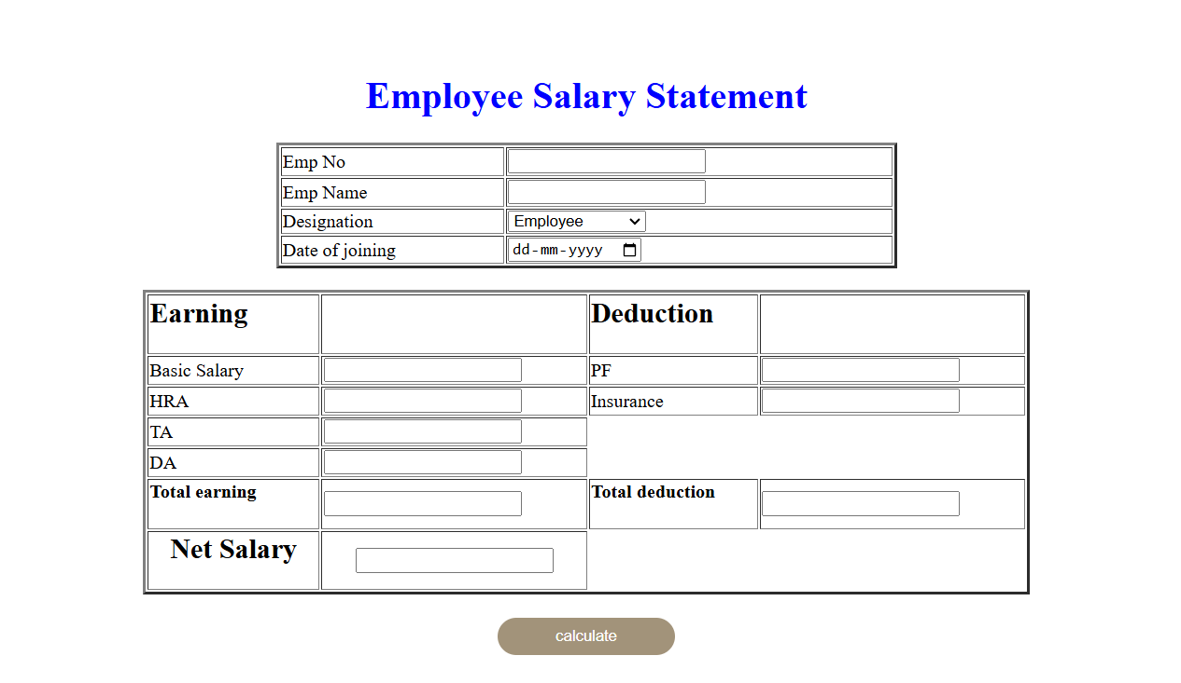

**2. Create a form to add a new product details to the product catalogue using React.**

**Code:**

import React, { useState } from 'react';

const App = () => {

const [productName, setProductName] = useState("");

const [description, setDescription] = useState("");

const [price, setPrice] = useState("");

const handleSubmit = (event) => {

event.preventDefault();

// Assuming you'll perform validation here before proceeding

// For simplicity, we'll just log the product details to the console.

console.log('Product Name:', productName);

console.log('Description:', description);

console.log('Price:', price);

// Add code here to submit the data to the server or state management system.

// You can also reset the form fields after submission if needed.

};

return (

<form onSubmit={handleSubmit}>

<br/><br/><br/><br/><br/>

<table align="center">

<tr><td><label htmlFor="p"><h1>PRODUCT DETAILS </h1></label></td></tr>

<tr><td><label htmlFor="productName">Product Name: </label></td>

<td> <input

type="text"

id="productName"

value={productName}

onChange={(e) => setProductName(e.target.value)}

required

/></td></tr>

<tr><td><label htmlFor="description">Description: </label></td>

<td> <textarea

id="description"

value={description}

onChange={(e) => setDescription(e.target.value)}

required

/></td></tr>

<tr><td><label htmlFor="price">Price:</label></td>

<td> <input

type="number"

id="price"

value={price}

onChange={(e) => setPrice(e.target.value)}

required

/></td></tr>

<tr><td><button type="submit">Add Product</button></td></tr>

</table>

</form>

);

};

export default App;

**Output :**

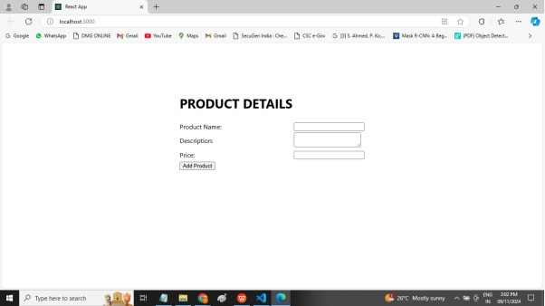

**3.Create a Spring Boot application to maintain Employee details such as employee ID, Employee Name, and Department. Design Entity or Data JPA class, Controller class and repository.**

**Code :**

package com.example.demo;

import org.springframework.boot.SpringApplication;

import org.springframework.boot.autoconfigure.SpringBootApplication;

import org.springframework.web.bind.annotation.GetMapping;

import org.springframework.web.bind.annotation.RestController;

@SpringBootApplication

@RestController

public class DemoApplication {

@GetMapping("/emp")

public String Employee (){

String Id="1";

String employeename="Amit";

String department="Developer";

String xx= "Id :" +Id + " <br>EmployeeName :" + employeename + " <br>Department : " + department;

return xx;

}

public static void main(String[] args) {

SpringApplication.run(DemoApplication.class, args);

    }

Output :

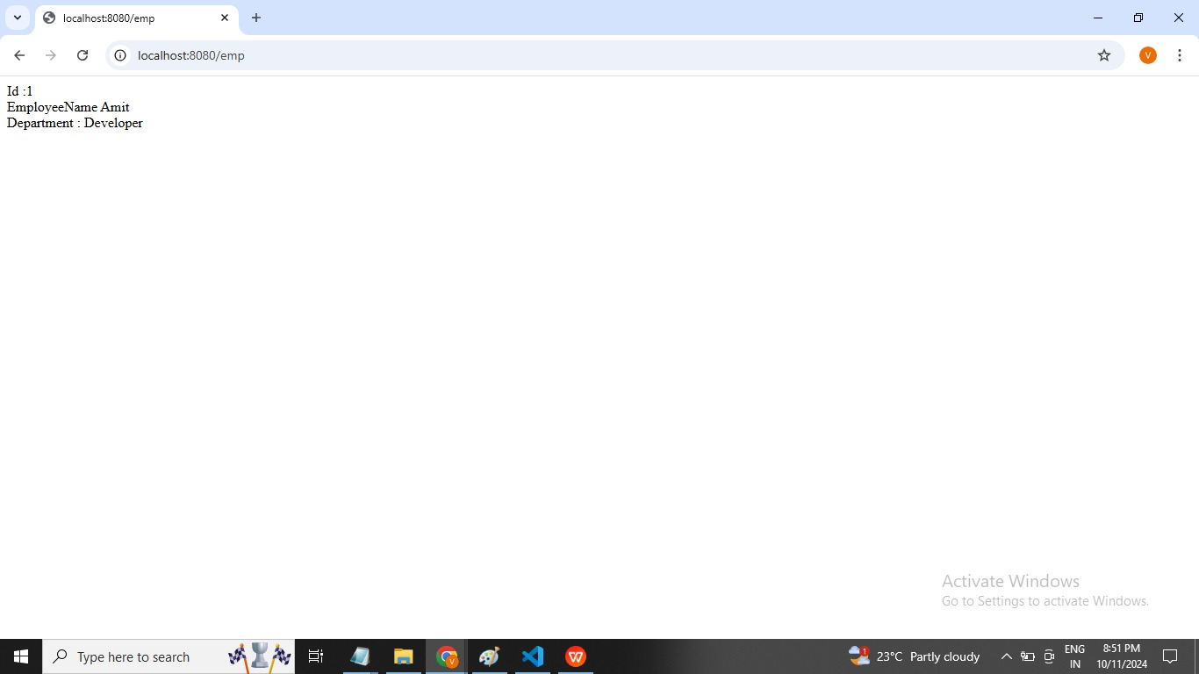

**4. Create REST Controller class to perform CRUD operations on product and corresponding request and responds DTO’s. The product class should contain data members product name, Product Category, Price. Use proper Spring Boot Annotations.**

**Code :**

package com.example.demo;

import org.springframework.boot.SpringApplication;

import org.springframework.boot.autoconfigure.SpringBootApplication;

import org.springframework.web.bind.annotation.GetMapping;

import org.springframework.web.bind.annotation.RestController;

@SpringBootApplication

@RestController

public class DemoApplication {

@GetMapping("/hello")

// Getters and Setters

public String getProductName() {

return "Product Name : Mouse <br> Category : Elecronics <br> Price : 500" ;

}

public static void main(String[] args) {

SpringApplication.run(DemoApplication.class, args);

    }

}

Output :

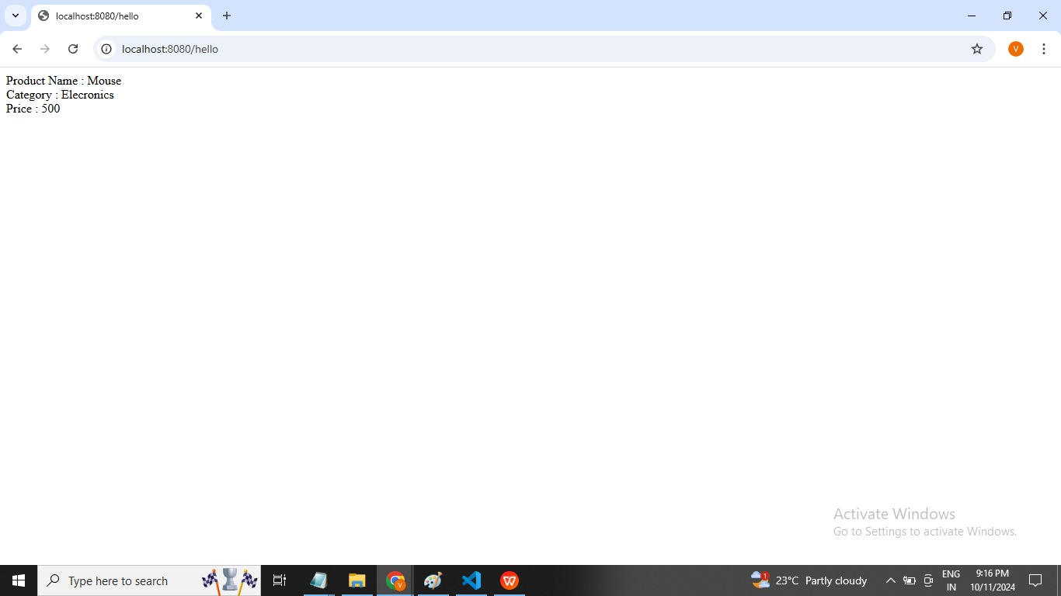

**5. Build Docker image with the Docker file, Create Docker image and run the docker container.**

**Ans :**

To build a Docker Image using a Docker file and run the container, follow these steps :

Create a Docker file :

Write the necessary instructions in a file named Dockerfile.

For example:

FROM python : 3.8

COPY ./app

WORKDIR /app

RUN pip install ./requirements.txt

EXPOSE 9999

CMD [“python”,’app.py’]

Build the Docker Image : Use the command ;

docker build -t hello-python : 1.0

Run the Docker Container : Execute :

Docker run-p 9998:9999 hello-python :1.0

***User Stories***

**1. Hotel Booking is an online Hotel room booking application that helps the users to book a room for staying at a particular place across Karnataka. This application allows users to login for booking a room. Users can search for the room at a hotel for a specific location. Once found, users can check the availability of a room for specific dates. Users can book a hotel required date. Once booked, users can get the booking details. Identify and write the user stories for this application.Write test cases for the above application.**

1. Sign-up: As an unauthorised user, I want to sign up for the HotelBooking application through a sign-up form, so that I can access to book a room.

Acceptance Criteria:

1. While signing up-Use Name, Username, Email, and Password and Confirm Password.

2. If sign up is successful, it will get automatically logged in.

3. If I sign up with an incorrect detail which is specified in step1, I will receive an error message for incorrect information.

4. If we are trying to sign up with an existing email address, we will receive an error message saying "email exists." .

**2.Login**

1.As an authorised user, I want to log in for the HotelBooking application, so that I can have access to the application.

Acceptance Criteria:

1. While logging in, Username and password are required.

2. After successful login, it will be redirected to the main page.

3. If we are trying to login with an incorrect username or password, then the error message will be displayed as "invalid login”.

**3. Searching a Room**

As an authorised user, I want to search for a room in the Hotel Booking application, so that I can book a room in a specific location.

Acceptance Criteria:

1. While searching, Valid location should be specified. 2. Checking for a room at a specific date always should be the current date and ahead of the current date.

**4. Booking Room**

As an authorised user, I want to book a room in the HotelBooking application, so that I can reserve the room in a specific location and date.

Acceptance Criteria:

1. While Booking, accommodation should be allotted according to the room size

2. One should select the valid payment method based on the price of the reserved room.

3. After successful payment one should get the booking details to registered mobile number and Email id.

**5. Logout**

As an authorised user, I want to log out of the Hotel Booking application, so that I can prevent unauthorised access of my profile.

Acceptance Criteria:

When I log out of my account, I will be redirected to the log-in page.

**Write test cases for the above application.**

1. Users are able to access the Hotel Booking Home page.

2. Validate the hotel booking Home page is rendered correctly for desktop as per the design specifications . 3. Validate the hotel booking Home page is rendered correctly for tablet as per the design specifications.

4. Validate the hotel booking Home page is rendered correctly for a mobile device as per the design specifications .

5. Validate hotel search fields are visible on screen.

6. User searches for a holiday to any place across Karnataka for a family of 2 adults and 2 children and makes a payment (End to End Test).

7. User makes a successful payment for their hotel booking.

8. User makes an unsuccessful payment of their hotel booking.

9. Hotel Room Unavailability – User searches for dates that are unavailable and system recommends 13 alternative dates or room types.

10. Users want to Amend an existing booking by adding an additional feature (e.g. increase length of stay / adding breakfast).

11. User wants to Verify the itinerary and print a Paper version.

12. User cancels their booking and system refunds money – Test Refund Conditions.

13. User cancels their booking and the system does NOT refund money – Test Refund Conditions.

14. User wants to make a group booking.

15. User wants to Validate Booking Page displays correct booking data– Visual check.

16. Confirm Payment Page is displayed when the user selects “Make Payment”.

17. End to End Test of Hotel Booking Engine.

**2. Flipkart is an online shopping application that helps its users to buy variety of authentic products. This application allows users to log in for buying products. Users cansearch for a product, sort the product list based on rating or price. Users can select the items and add them to the cart. Once the selection is done, users can go to the cart page for payment. Identify and write the user stories for this application.**

**Registration/Sign-up:**

As a shopper, I want to sign up for the Flipkart application through a New user form, so that I Can get access to buy a variety of products.

Acceptance Criteria:

1. While signing up-Valid Phone Number/Email Id and OTP/Password.

2. If sign up is successful, it will get automatically logged in.

3. If I am trying to sign up with an invalid phone number/Email Id, I will receive an error message to enter valid information.

4. If we are trying to sign up with an existing phone number/Email Id, we will receive an error message saying "you are already registered."

**Login**

As an authorised shopper, I want to log in for the Flipkart application, so that I can have access to the application for searching and buying products. Acceptance Criteria:

1. While logging in, Phone number/Email Id and OTP/Password are required.

2. After successful login, it will be redirected to the main page.

3. If we are trying to login with an incorrect mobile number/Email Id or OTP/Password, then an error message will be displayed as "invalid credentials”.

**View a List of Products**

As a Shopper I want to view a list of products so I can select some items to purchase Acceptance Criteria:

1. See a thumbnail image for each product.

2. Click to view details for product.

3. Add to cart from detail page.

4. Search for a product.

5. View products by category.

**Review a Cart**

As a Shopper I want to review my cart so I can make adjustments prior to checkout.

Acceptance Criteria:

1. View quantities and items in the cart.

2. See a total cost before tax and shipping.

3. Remove items.

4. Adjust quantity of items.

5. Click to navigate to a product detail page.

**Check out**

As a Shopper I want to check out so I can get my products shipped to me.

Acceptance Criteria:

1. Trigger checkout from any page, if there are items in the cart.

2. Enter a shipping address.

3. Enter a billing address.

4. Enter a credit card number.

5. Show total including tax and shipping before finalising.

6. Show Confirmation message after finalising.

7. Verify payment through our payment processor.

**Review Orders**

As a Shopper I want to review my orders so I can see what I have purchased in the past.

Acceptance Criteria:

1. View a list of open and completed orders.

2. See the status of the order.

3. Navigate to the details of the order.

4. Include a tracking number if the order is shipped but not delivered.

5. Contact customer service about an order from the details page.

**Logout**

As a Shopper, I want to log out of the Flipkart application, so that I can prevent unauthorised access of my profile.

Acceptance Criteria:

When I log out of my account, I will be redirected to the log-in page.

Write test cases for the above application.

**Test Cases for Flipkart Website Login Page**

* Check that there are proper validations on the Login Page.
* Check for an error message if the Email, password, or any required field is left blank.
* Check the validations on the Email and password.
* When you log in, check that you stay logged in as you browse products. Also, you need to test the behaviour.
* When the user doesn’t interact with the site for some time, then the user has been logged out after the session times out.
* When you are logged in, log out and make sure you are logged out and that you cannot access any of the account’s pages.

**Test Cases for Flipkart Website Search Page**

* Check that the products displayed are related to what was searched for.
* Check that the products should display an image, name, price, and maybe customer ratings and number of reviews. the more relevant product for the search term is displayed on the top for a particular search 15 term.
* Check that all items on the next page are different from the previous page, i.e., no duplicates.
* Check that when both sorts and filters have been applied, they remain as we paginate or more products are loaded.
* Check that the count of products is correctly displayed on the search result page for a particular search term.
* Check that filtering functionality correctly filters products based on the filter applied.
* Check that filtering works correctly on category pages.
* Check that filtering works correctly on the search result page.
* Check that the correct count of total products is displayed after a filter is applied.
* Check that all the sort options work correctly – correctly sort the products based on the sort option chosen.
* Check that sorting works correctly on the category pages.
* Check that sorting works correctly on the search result page.
* Check that sorting works correctly on the pages containing the filtered result, after applying filters.
* Check that the product count remains intact irrespective of the sorting option applied.

**Test Cases for Flipkart Website Shopping Cart**

* Users should be able to add a product to the cart.
* Item count should be incremented when the user adds the same product again.
* Taxes should be applied according to the delivery location.
* Users should be able to add items to the cart.
* Users should be able to update items in the cart.
* Checkout should happen successfully for the items added to the cart.
* Shipping costs for different products are added to the cart.
* Coupons should be applied successfully to the cart.
* The cart should retain the items even when the app is closed.
* Payment Page Test Cases Check that After filling the shipping address and payment, the product is purchased successfully.
* Check that Different payment types should be present, e.g., Credit Card, PayPal, Bank Transfers, Instalments, etc.
* Check the security of the client’s card details when entered for payment.

**Test Case for Flipkart Website – Post Order Page**

* Email and order id should be sent after placement of order.
* Users should be able to cancel the order.
* There should be a facility for users to track the order.
* Users should be able to return/replace the product post-delivery

**3.Swiggy is an online food ordering application that helps its users to by variety of the authentic food items. This application allows users to log in for ordering food. Users can search for their favorite food based on rating or price. Users can select the items and add to the cart. Once the selection made go to the payment page and make payment. Write the user story for this application.**

**Registration**

**Sign up:**

As a foodie I want to sign up for Swiggy application through a new user form so that I can get access to order food of my favorite.

Acceptance Criteria:

* While signing up valid phone number/email id and OTP/password.
* If sign up is successful it will get automatically logged in.
* If I am trying to login with an invalid phone number/email id I will receive an error message to enter a valid information.
* If we are trying to sign in with an existing phone number/email id we will receive an error message saying you are already registered.

**Login As an authorized customer**

I want to login for application so that I have access to the application for searching and ordering food.

**Acceptance Criteria**

* While log in phone number/emailed and OTP/password are required.
* After successful login it will be redirected to the main page.
* If we are trying to log in with incorrect mobile number/email id or password, then error message will displayed as invalid credentials.

**Order Creation:**

* As a customer I should be able to browse through the menu and look at various food option and along with their price.
* As a customer, I should be able to select items from the menu and look the menu and add them to cart.
* As a customer, I should have cart containing all the chosen items.
* As a customer, I should be able to remove items from my cart or increase item.
* As a customer, I should be able to view the item bill for my order along with price of each item.

**Acceptance Criteria:**

* Categorized menu with prices is visible and enabled with selection choices as soon as the customer chooses item.
* See a thumbnail image for each product • Click to view details for product.
* Add to cart from details.
* Search for item.
* View food item category.

**Order Completion**

As a customer I should be able to provide feedback for service and the food.

**Acceptance Criteria**

All the feedbacks are recorded in the database for further improvement.

**Logout**

As a customer I want to log out of application so that I can prevent unauthorized access of my profile

Acceptance Criteria:

When I log out of account I will redirected to the log in page.

**Test cases for swiggy application**

* Verify that when user open online food ordering application then it should be asked for the user location.
* Verify that user is able to login the application without registration or not.
* Verify that the user is able to sign up or login with mobile number or not.
* Verify that the user is able to sign up or login with email address or not.
* Verify user is able to redirect on home page screen without login.
* Verify that logo of online food ordering application on the login screen.
* Verify that application name is displayed on screen.
* Verify that user is able to skip login screen or not.
* Verify that links on the long in page should be working properly or not.

**Test Cases for online Food Ordering System Search Functionality**

* Verify that if user enters valid food name, then search result should be displayed.
* Verify that if user enter valid restaurant name, search result should be displayed.
* Verify that if user search by valid food name, then relevant food search result should be displayed.
* Verify that if user search by valid restaurant name, then relevant food search result should be displayed on the screen.

**Test case for Ordering page**

* Verify that the restaurant name with rating should be displayed.
* Verify that user should be able to see veg and non veg category on the ordering page or not.
* Verify that user is able to see billing discount on the order page or not.
* Verify that user is able to see total number of review on the ordering page or not.
* Verify that user is able to add food items option is displayed on the page or not.
* Verify that user is able to see items with its price or not Test Cases for cart checkout page.
* Verify that user should be able to see added items into cart.
* Verify that user is able to increase the quality of the food items from the cart page or not.
* Verify that users should be able to delete food items from the cart page.
* Verify that user is able to edit delivery address or not.
* Verify that user is able to change delivery address or not.
* Verify that user is able to select payment method on cart checkout page.
* Verify that user is able to place order from the cart checkout page or not.

**4.BookMyShow is an online movie ticket booking application that helps its user to book movie tickets by logging in. Users can find their movie from the listings. After booking is confirm the details are sent to user.. Identify and write the user stories for this application.**

**Registration**

**Sign-up:**

As an unauthorized user, I want to sign up for the BookMyShow application through a sign-up form, so that I can access to movies list.

**Acceptance Criteria:**

1. While signing up-Use Name, Username, Email, and Password and Confirm Password.

2. If sign up is successful, it will get automatically logged in.

3. If I sign up with an incorrect detail which are specified in step1, I will receive an error Message for incorrect information.

4. If we are trying to sign up with an existing email address, we will receive an error Message saying "email exists."

**2. Login**

As an authorized user, I want to log in for BookMyShow application, so that I can have access to the application.

**Acceptance Criteria:**

1. While logging in, Username and password are required.

2. After successful log in, it will be redirected to the main page.

3. If we are trying to login with incorrect username or password, then error message will be displayed as "invalid login".

**3. Searching a movie**

As an authorized user, I want to search for a movie in BookMyShow application, so that 1 can book a movie ticket in a specific theater.

**Acceptance Criteria:**

1. While searching, Valid theater should be specified.

2. Checking for availability of a movie ticket on specific date always should be current date and ahead of the current date.

**4. Booking ticket**

As an authorized user, I want to book a ticket in BookMyShow application, so that I can reserve the seat in a specific theater and date.

**Acceptance Criteria:**

1. While Booking, accommodation should be allotted according to the room size.

2. One should select the valid payment method based on the price of reserved room.

3. After successful payment one should get the booking details to registered mobile Number and E-mail id.

**5. Logout**

As an authorized user, I want to log out of application, so that I can prevent unauthorized access of my profile.

**Acceptance Criteria:**

When I log out of my account, I will be redirected to the log-in page.

**Test cases for the above application.**

**Test Cases for the Login Page:**

* Verify that the login page loads correctly and is accessible from the website's homepage.
* Check that the login credentials are case sensitive and the appropriate message is displayed if the user enters incorrect information.
* Verify that the "Forgot Password" option works as intended, allowing users to reset their password in case they forget it.
* Ensure that the system limits the number of unsuccessful login attempts to prevent brute-force attacks.

**Test Cases for the Registration Page:**

* Verify that the registration page is accessible from the website's homepage and loads correctly.
* Check that the system validates the user's information, such as email address, phone number, and password complexity.
* Ensure that the system does not allow duplicate email addresses or phone numbers.
* Verify that the user receives an email or SMS confirmation after registering.

**Test Cases for the Ticket Booking Page:**

* Ensure that the ticket booking page displays accurate information about the event, such as the date, time, and venue.
* Check that the system limits the number of tickets a user can purchase to prevent scalping.
* Verify that the system displays the total cost of the ticket purchase, including any taxes andfees.
* Ensure that the system accepts multiple payment options, such as credit/debit cards, PayPal, and mobile wallets.

**Test Cases for the Payment Gateway:**

* Verify that the payment gateway is secure and encrypts user information to prevent fraud.
* Check that the payment gateway accepts different currencies and displays the correct conversion rates.
* Ensure that the payment gateway sends a confirmation email or SMS to the user after the transaction is complete.

By following these test cases, you can ensure that your online ticket booking system is reliable and user-friendly. Thorough testing will help you identify and fix any issues before your system goes live, ensuring a positive experience for your customers.

**5.GPay is a digital payment application that helps its users to do variety of money transaction.**

**User Story:**

**Registration/Sign-up:**

As a new user, I want to sign up for the GPay app so that I can access the app for digital payment.

**Acceptance Criteria:**

* Mobile number linked to bank account should be used for app registration on smart phone.
* Choose google account associated with user smart phone.
* Verify the registered mobile number with OTP.
* Addition security has to enabled either by setting password or 4-digit pin.

**User Story:**

**Bank Account Linking As a registered user, I want to link my bank account so that I can do any digital payment transaction.**

**Acceptance Criteria:**

* Must add preferred bank name registered with user mobile number.
* App must find the account number linked to mobile number for the preferred bank.
* User should set 4 or 6-digit pin for authorizing the digital payment transaction.
* User must scan QR code to transfer money amount will be automatically displayed or user must enter the amount.
* User must enter mobile number, amount to pay to his friends/contact.
* For bank transfer, user must enter account number, IFSC code, account holder's name. After successful linking, user can pay by entering desired amount.
* For bill payment, bill needs to be liked to service providers. Once liked user gets outstanding amount to be paid.
* User must get confirmation message, notification for all the above digital payment.

**User Stories: Utilities As a user, I want to check my transaction, balance, offers & reward so that I can plan my next transaction.**

Acceptance Criteria:

* User must get bank balance after validating security pin.
* User must be able to check the transaction history, filter transaction by name, date, phone number etc.
* User must be able to check, apply the offers and rewards provided in the app.

**Test cases for the above application.**

**Test Cases for the Registration Page:**

* Verify whether user is able download Gpay app from play store and installation of app on different smartphone like android, ios etc is possible or not.
* Verify 4-digit pin is validated for login authentication.
* Check whether mobile number is verified with one time password.

**Test Cases for the Bank Account Registration**

* Check when mobile number is entered, bank details linked to registered mobile number is fetched or not.
* Check whether user is able to set 4-digit transaction pin for addition security.

**Test Cases for the Digital Payment**

* Ensure camera is opened for scanning when scan QR code option is selected.
* Ensure when valid mobile number is entered, authorized Gpay recipient name is displayed.
* Check whether account number and IFSC validation are done for bank transfer.